**A452 JavaScript**

**William Wood**

**7474**

**For June 2017**

**Task 3**

**My plan for completing task 3:**

I am going to start by making a list of assets that I need to gather to complete the task. I'm then going to create a success criteria to evaluate my code against later. I will research the best place to store the assets and why. I will write a script that changes the traffic lights when a button is clicked. I will test my code and evaluate it against the success criteria.

**Asset list:**

I will need:

-Red traffic light:

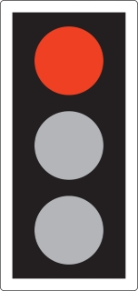

-Red amber traffic light:

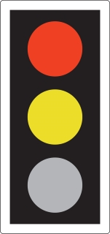

-Green traffic light

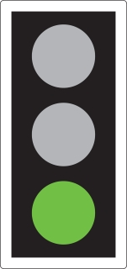

-Amber traffic light:

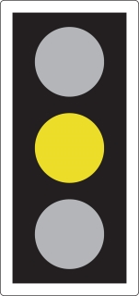

I decided to get my assets from the UK Government website (<https://www.gov.uk/guidance/the-highway-code/light-signals-controlling-traffic>) as the artwork is designed clearly and is licenced under the Open Government Licence (<https://www.nationalarchives.gov.uk/doc/open-government-licence/version/3/>) so the images can be used freely any copyright issues.

The filenames are shortened versions of the colours, for example the red traffic light is called tl-red.jpg. This makes finding the correct assets easy and simple to type in.

I have stored the images in the Jpeg format because

**Success criteria:**

To be successful in this task, I must:

-Create a traffic light sequence in JavaScript that runs on the click of a button

-Test to make sure the code works as expected and take remedial action if needed

-Do research on where the best place to store assets is.

-Explain and annotate every line of my code.

**Screenshot of my code:**

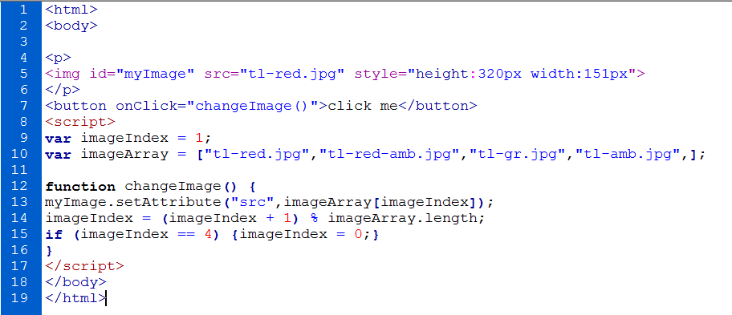

**A screenshot of my array that stores the traffic light assets:**



**Testing of the code:**

Initial run:

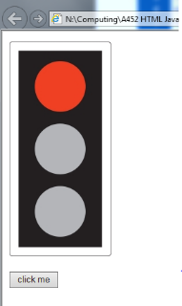

First button press:

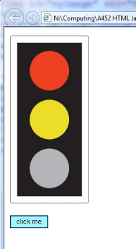

Second button press:

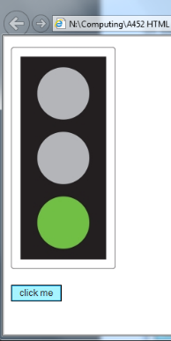

Third button press:

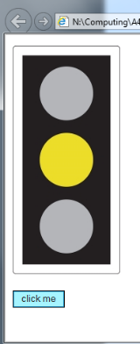

Fourth button press:

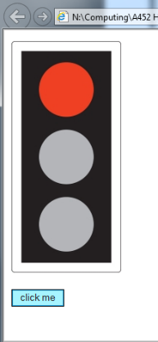

Fifth button press (to test the loop):

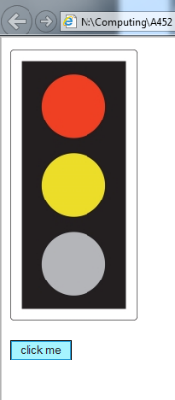

These screenshots show no issues with the order of the traffic lights and the loop works with no issues as well.

**Remedial Action Taken:**

I did not have to take any remedial action with my code because it worked on the initial run and no errors were found.

**Annotation of my code:**

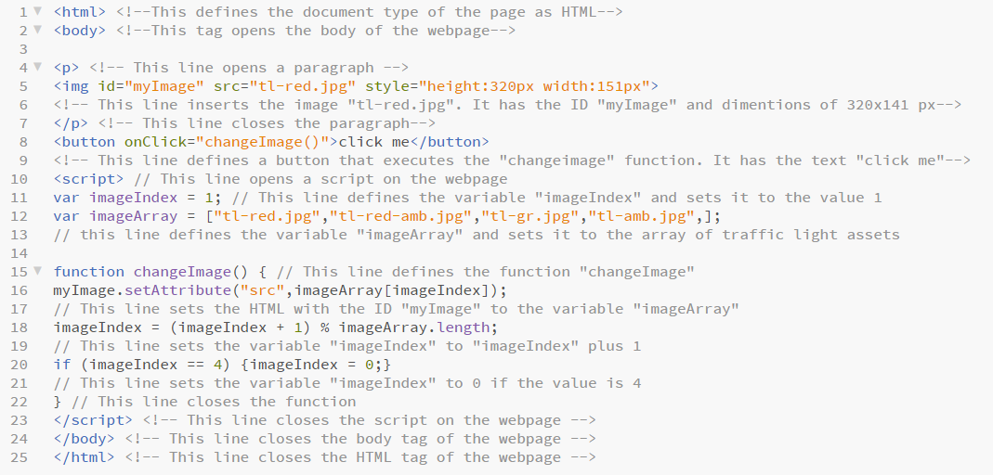

I annotated all of my HTML code using the comment tags **<!--** and **-->**. I also annotated all of my JavaScript code with “//”. This makes it easy for other people to see what each line of the code does in detail. This also helps with troubleshooting as you can clearly see what each tag does and how it works.

**Evaluation against the success criteria:**

|  |  |  |
| --- | --- | --- |
| **Criteria Point** | **How have I met the point?** | **Evidence** |
| -Create a traffic light sequence in JavaScript that runs on the click of a button | I have created a working webpage where the traffic lights advance on a click of a button. This is shown when the YELLOW button is pressed the traffic light advances. |  |
| -Test to make sure the code works as expected and take remedial action if needed | There was no issues with my code so no remedial action needed to be taken. Testing is shown above. | **See above** |
| -Do research on where the best place to store assets is. | I did reseach showing what place to gather assets. I decided to gather them from gov.uk because they were copyright free | **N/A** |
| -Explain and annotate every line of my code. | I have annotated every line of my code to explain what each one does. | **See above** |